Project Proposal:
An Evaluation of Algorithmic Bias and Fragility in Rate My Professor Sentiment Analysis Model

Danny D. Munoz and Daniel Nguyen
Texas A&M University - Central Texas
MATH-5389: AI Mathematics
Dr. Mienie Roberts
June 25, 2026

List of Abbreviations

Abbreviation | Full Term
AI | Artificial Intelligence
NLP | Natural Language Processing
RMP | Rate My Professor
SVM | Support Vector Machine
TF-IDF | Term Frequency-Inverse Document Frequency

Project Proposal:
An Evaluation of Algorithmic Bias and Fragility in Rate My Professor Sentiment Analysis Model
Concept
Rate My Professor is widely used by students to review instructors and choose courses, however, its ratings are highly emotional that reflect each student’s individual opinion and experience. Sentiment analysis gives us a neutral tool to classify reviews into positive or negative (Gong et al., 2022). One caveat is that these machine learning models can be fragile, prone to bias, sensitive to minor wording changes, and easy to be influenced by biases in the training data. Also, when professors have high academic standards, students often leave angry reviews, which causes the model to mix up tough grading with terrible teaching and label them as pure negativity. On the other hand, the site's reviews are filled with informal language, slang, sarcasm, and emotion; they offer an ideal dataset for studying how classical machine learning handles noisy, emotional text that will increase the complexity of NLP models.
Scope
The scope of this project includes training, testing, and evaluating baseline machine learning models on a pre-labeled dataset of RMP reviews. Deliverables include trained baseline models, a series of stress tests, and a final audit report. After initial training and evaluation, the project will stress-test models through overfitting experiments, adversarial examples, and bias test cases. These tests will determine whether strong accuracy is hiding underlying weaknesses, such as algorithmic fragility or harmful bias that could lead to false predictions. The audit report will document how the models succeed, where they fail, and why those failures matter in context. The project is intended for beginner machine learning and data analytics students, constraining the work to models built from scratch with a pre-labeled dataset.

Group Membership
Danny D. Munoz and Daniel Nguyen will collaborate on the project showcase, written components, artifact, design document, and evaluation report via shared documents and ongoing communication. Nguyen will serve as the primary content writer, while Munoz will handle revising and editing. The video walkthrough will be co-created, with Munoz handling 60-70% of the recorded demonstration, and Nguyen presenting the remainder.
Mathematical Topics Used
Term Frequency-Inverse Document Frequency
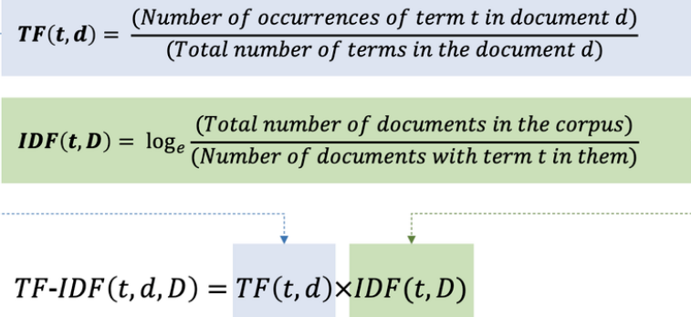
Prior to feeding text into a classifier the words must be converted to numbers. TF-IDF measures how important a word is to a specific review within the entire dataset (Lu, 2025).

Figure 1: TF-IDF (Hashim et al., 2023)
Logistic Regression
Logistic Regression calculates the weighted sum of the TF-IDF features and passes it through a sigmoid function 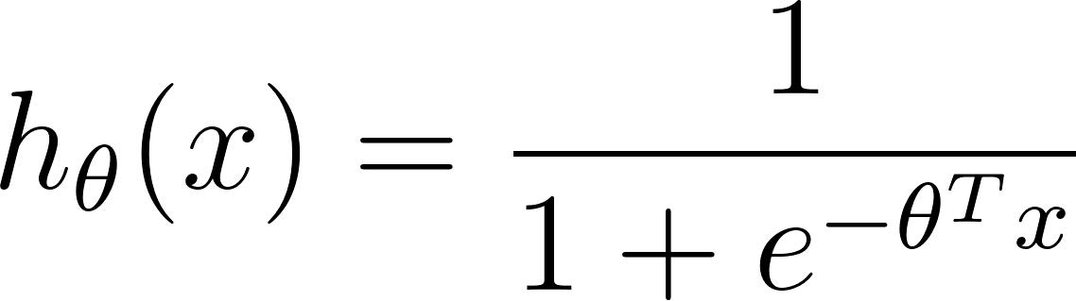 to output a probability between 0 and 1 (Pradeepa et al., 2024). To maximize the accuracy, it is a must to minimize the cost function as much as possible. Regularization to the model is required due to the stress-test with overfitting later on.
Loss function:

Support Vector Machine
For high-dimensional text data, a Linear SVM is often the most accurate traditional algorithm due to finding the hyperplane that separates the positive reviews from the negative reviews with the widest possible margin. The Hyperplane is 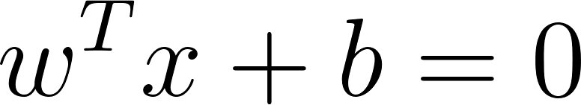 with w being the weight vector, x is the input vector, and b is the bias. Text data is rarely perfectly separable, by using a "soft margin" SVM it allows for some misclassifications using slack variables . 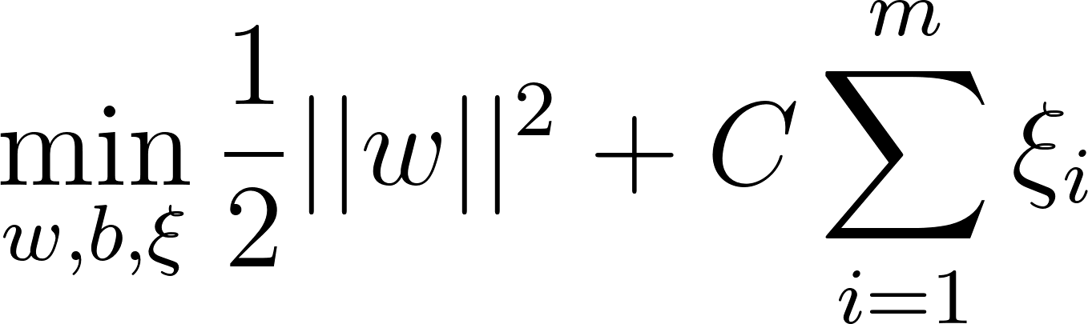 (Subject to the constraints)
Overfitting and Failures
To overfit the Logistic Regression and SVM models, the algorithm is forced to memorize the training data instead of learning the patterns of data by disabling the regularization, increasing the inverse penalty parameter, and increasing the cost parameter of the SVM model. The models will memorize and perform very well on the small training dataset, but perform poorly on new data being fed and constantly misclassify reviews about minority instructors (Liu et al., 2023). Because the dataset has a lot of emotional reviews that contain slang, sarcasm and so on, they can fool the mo, which will lead to a false positive (Savini & Caragea, 2020). Twenty reviews will be created and fed into the testing model covering four types of failure cases: true positive review, true negative review, false positive review, and false negative review.

References
Diaz, M., Johnson, I., Lazar, A., Piper, A. M., & Gergle, D. (2018). Addressing Age-Related Bias in Sentiment Analysis. Proceedings of the 2018 CHI Conference on Human Factors in Computing Systems, 1–14. https://dl.acm.org/doi/10.1145/3173574.3173986
Gong, X., Ying, W., Zhong, S., & Gong, S. (2022). Text Sentiment Analysis Based on Transformer and Augmentation. Frontiers in Psychology, 13. https://www.frontiersin.org/journals/psychology/articles/10.3389/fpsyg.2022.906061/full
Hashim, A., Mohammad-Reza Feizi-Derakhshi, & Pedram Salehpour. (2023). Enhancing Fake News Detection by Multi-Feature Classification. IEEE Access, 11, 139601–139613. https://doi.org/10.1109/access.2023.3339621
Liu, M., Zhang, Z., Zhang, Y., et al. (2023). Automatic Generation of Adversarial Readable Chinese Texts. IEEE Transactions on Dependable and Secure Computing, 20, 1756–1770. https://dl.acm.org/doi/abs/10.1109/TDSC.2022.3164289
Lu, J. (2025). Text vectorization in sentiment analysis: A comparative study of TF-IDF and Word2Vec from Amazon Fine Food Reviews ITM Web of Conferences, 70, 03001. https://www.itm-conferences.org/articles/itmconf/pdf/2025/01/itmconf_dai2024_03001.pdf
Pradeepa, S., Jomy, E., Vimal, S., et al. (2024). HGATT_LR: transforming review text classification with hypergraphs attention layer and logistic regression. Scientific Reports, 14. https://www.nature.com/articles/s41598-024-70565-6
Sarlis, S., & Maglogiannis, I. (2020). On the Reusability of Sentiment Analysis Datasets in Applications with Dissimilar Contexts. IFIP Advances in Information and Communication Technology, 409–418. https://beei.org/index.php/EEI/article/download/4682/3183
Savini, E., & Caragea, C. (2020). A Multi-Task Learning Approach to Sarcasm Detection (Student Abstract). Proceedings of the AAAI Conference on Artificial Intelligence, 34, 13907–13908. https://ojs.aaai.org/index.php/AAAI/article/view/7226
Semary, N. A., Ahmed, W., Amin, K., Pławiak, P., & Hammad, M. (2024). Enhancing machine learning-based sentiment analysis through feature extraction techniques. PLOS ONE, 19, e0294968. https://journals.plos.org/plosone/article?id=10.1371/journal.pone.0294968
Zheng, X., Vastrad, S., He, J., & Ni, C. (2023). Contextualizing gender disparities in online teaching evaluations for professors. PLOS ONE, 18, e0282704. https://journals.plos.org/plosone/article?id=10.1371/journal.pone.0282704

